Microcontroller Experiments using Arduino or MSP430:

a. Touch sensor

b. Tracking sensor

c. Tap sensor

1. Touch sensor

Components Required:

TTP223B

Arduino

Jumper wires

Bread Board

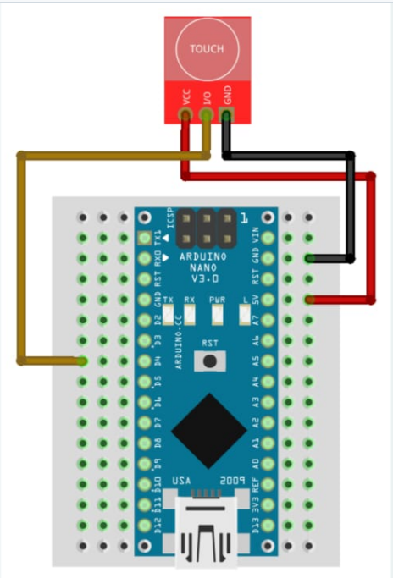

Program:

#define BUTTON_PIN 4

struct touch {

byte wasPressed = LOW;

byte isPressed = LOW;

};

touch touch;

void setup()

{

pinMode(BUTTON_PIN, INPUT);

Serial.begin(115200);

}

void loop()

{

touch.isPressed = isTouchPressed(BUTTON_PIN);

if (touch.wasPressed != touch.isPressed) {

Serial.println("Touch pressed");

}

touch.wasPressed = touch.isPressed;

}

bool isTouchPressed(int pin)

{

return digitalRead(pin) == HIGH;

}

1. Tracking sensor

Components Required:

KY-033 Line Tracking Sensor Arduino circuit and Programming

Arduino

Jumper wires

Bread Board

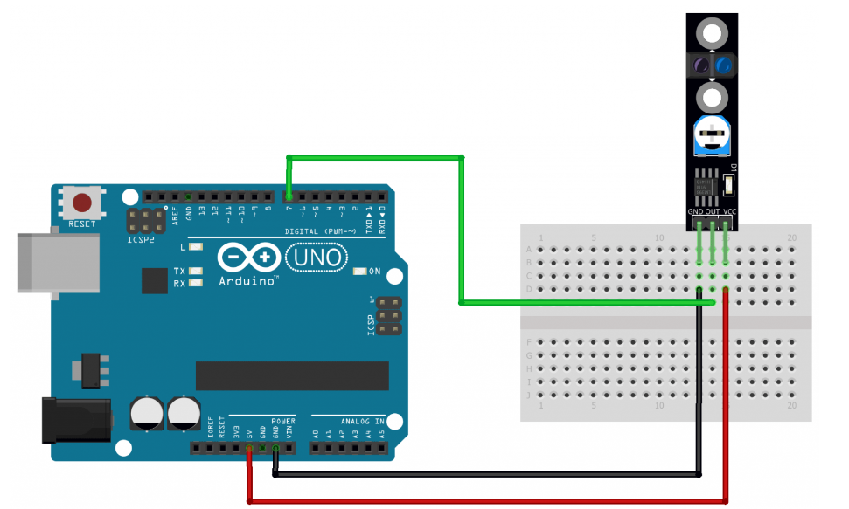

Program

int sensorPin = 7; // line detection sensor interface

int val; // variable to store sensor reading

void setup() {

pinMode(sensorPin,INPUT); // define sensor as input

Serial.begin(9600); // initialize serial communication with PC

}

void loop() {

val = digitalRead(sensorPin); // read value from sensor

if (val == HIGH) {

Serial.println("Line detected");

} else {

Serial.println("Line NOT detected");

}

delay(500);

}

1. Tap Sensor

Components Required:

* Arduino board (e.g., Arduino Uno)
* Tap Module
* Jumper wires
* Breadboard (optional)

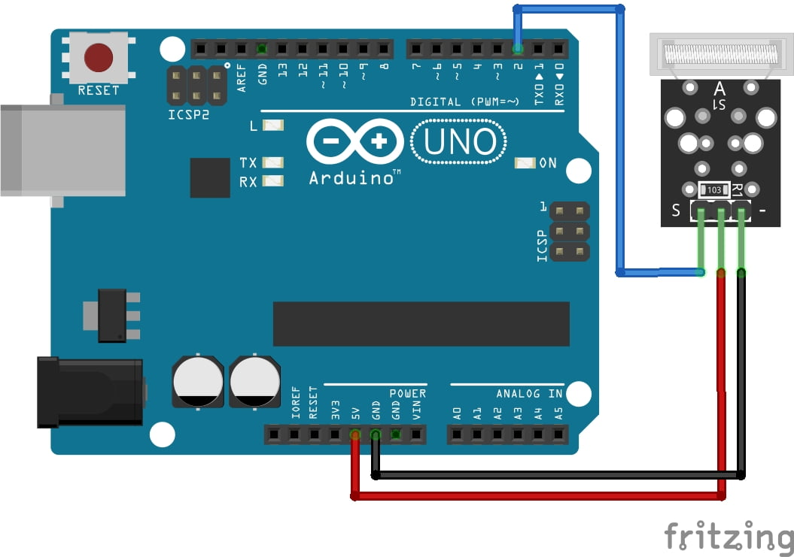

**Program:**

#define tapSensorPin 2 // Change this to the pin you're using

volatile bool tapped = false; // Flag to indicate tap detection

void setup()

{

pinMode(tapSensorPin, INPUT_PULLUP); // Set the sensor pin as input with internal pull-up resistor

attachInterrupt(digitalPinToInterrupt(tapSensorPin), tapDetected, RISING); // Attach interrupt to the pin for rising edge detection

Serial.begin(9600); // Initialize serial communication

}

void loop() {

if (tapped) {

Serial.println("Tap detected!");

tapped = false; // Reset the tap flag

// Add actions or responses when a tap is detected

}

delay(100); // Delay for stability and to prevent rapid consecutive detections

}

void tapDetected() {

tapped = true; // Set the tap flag when a rising edge is detected

}